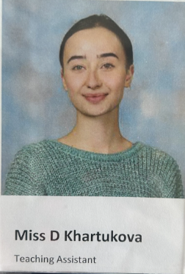
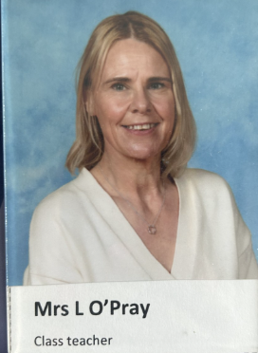
Sycamore Class 2026/7
Hello again, Sycamore Class!

I am so looking forward to teaching you all again in September. We will be Sycamore Class and are lucky enough to have an air- conditioned classroom to spend year 4 in.
We have a brilliant year ahead of us and lots of exciting topics to learn about, I know lots of you are looking forward to finding out more about the Romans.
I have included a couple of photographs of Sycamore classroom but I plan to spend some of the Summer holidays giving it a bit of a spruce up ready for September. When you come back, there will be pegs for each of you just outside our classroom and trays for each of you inside.
I hope you all have an amazing Summer and enjoy relaxing and having fun.
Roll on September!
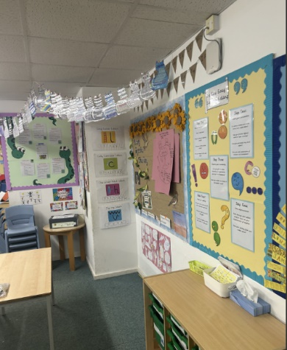
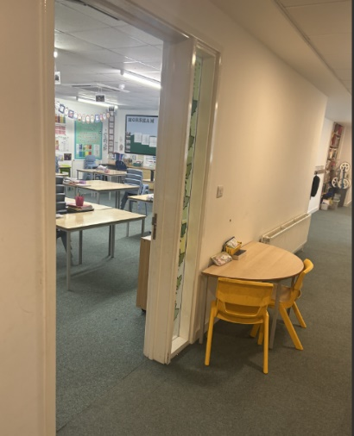
From,
Mrs O’Pray

