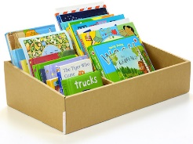 | Christmas Holiday Reading Challenge |  |  |  |  |  | Christmas Holiday Reading Challenge
Take it in turns to read a page aloud with someone else  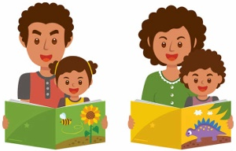 |  | Read a Christmas story 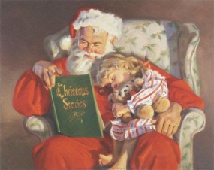 | 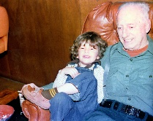  Read to a relative |  |  | Take it in turns to read a page aloud with someone else |  | Read a Christmas story | Read to a relative
Read in your pyjamas  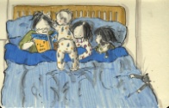 |  | Read something from espresso about your class topic  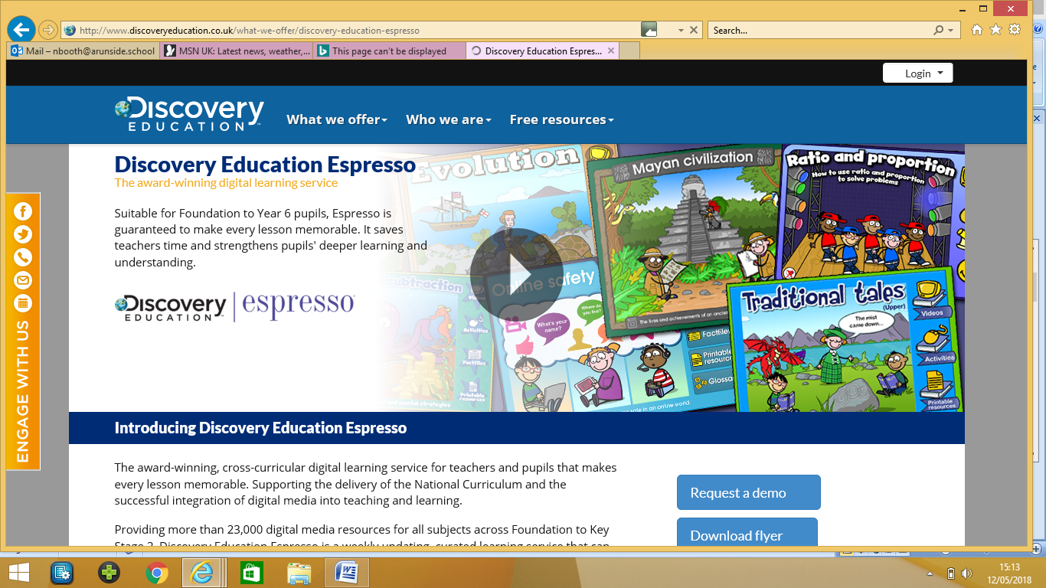 | Read a book about your class topic  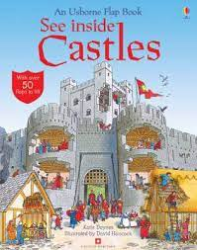 |  |  | Read in your pyjamas |  | Read something from espresso about your class topic | Read a book about your class topic
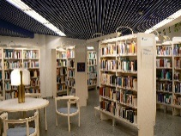  Read a library book |  | 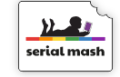  Read a book from Serial Mash on Purple Mash |   Read in an unusual place (take a photo to prove it!) |  |  | Read a library book |  | Read a book from Serial Mash on Purple Mash | Read in an unusual place (take a photo to prove it!)
Tick each challenge that you complete and return this card to school after Christmas. |  |  |  |  |  | Tick each challenge that you complete and return this card to school after Christmas.

Name: __________________________  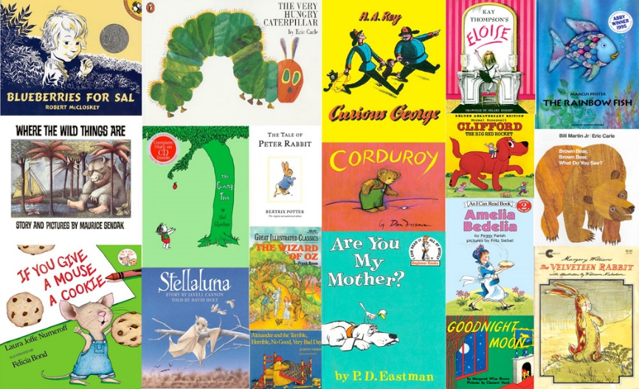  Year 1  Christmas Holiday Reading Challenge   |  | Name: __________________________  Year 1  Christmas Holiday Reading Challenge

