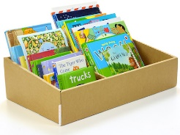 | Summer Holiday Reading Challenge |  |  |  |  |  | Summer Holiday Reading Challenge
Take part in the Summer Reading challenge at the library  https://yourvoice.westsussex.gov.uk/2025-summer-reading-challenge-story-garden |  | Read a book that you chose from the library   | Read a book set at the seaside  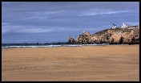 |  |  | Take part in the Summer Reading challenge at the library  https://yourvoice.westsussex.gov.uk/2025-summer-reading-challenge-story-garden |  | Read a book that you chose from the library | Read a book set at the seaside
Read a book outside  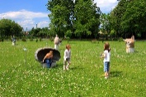 |  | Read a different book each week   |   Read a book by an author new to you |  |  | Read a book outside |  | Read a different book each week | Read a book by an author new to you
Read a comic   |  | 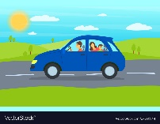  Read a book about a journey. | Read in an unusual place (take a photo to prove it!)  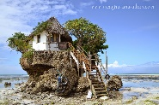 |  |  | Read a comic |  | Read a book about a journey. | Read in an unusual place (take a photo to prove it!)
Tick each challenge that you complete and return this card to your class teacher at school after the Summer holidays. |  |  |  |  |  | Tick each challenge that you complete and return this card to your class teacher at school after the Summer holidays.

Name: ______________________  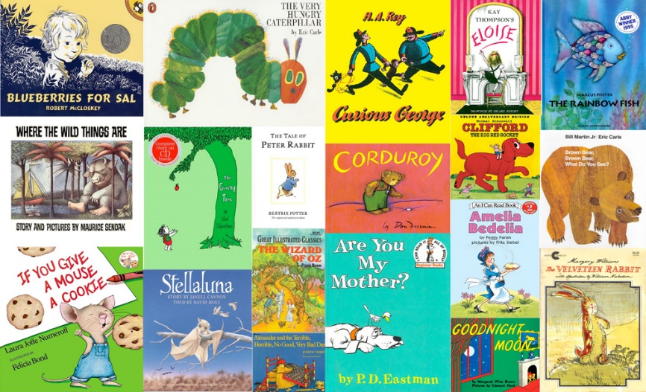  Year 1  Summer Holiday Reading Challenge   |  | Name: _____________________  Year 1  Summer Holiday Reading Challenge

