

**Save our Planet**

|  |  |  |
| --- | --- | --- |
| **Key Figures** | | |
| **Greta Thunberg** |  | A Swedish environmental activist. At just 16 years old, Greta Thunberg started an international youth movement against climate change. The Swedish teenager first staged a "School Strike for Climate" in front of the Swedish Parliament in August 2018.She continued to gain international attention after speaking at the U.N. Climate Talks in Poland in December 2018. |
| **Kate Raworth** |  | She proposed ways of measuring a successful society that don’t rely on more and more production and spending. Her idea of ‘doughnut economics’ is based on the idea that people need to live in balance with the planet |
| **John Francis** |  | After watching with dismay as an oil spill engulfed San Francisco Bay, USA in 1971, he took a stand. For the next 22 years, he refused to take motorised transport in protest, took a 17-year vow of silence (apart from one phone call to his Mum) so that he could really listen to people, and walked across the width of 48 American states and beyond to raise people’s awareness of environmental issues. He became a United Nations Environmental Program Goodwill ambassador. |

|  |  |
| --- | --- |
| **Key Vocabulary** | |
| Atmosphere | A layer of gas that surrounds the Earth |
| Carbon Dioxide | A gas that is formed by burning fuels, by the breakdown or burning of animal and plant matter, and by the act of breathing and that is absorbed from the air by plants in photosynthesis. |
| Climate change | A large-scale, long-term shift in the planet's weather patterns and average temperatures. |
| Climate | The average of the weather conditions in an area over a long period of time. |
| Drought | A long period of very low rainfall leading to shortage of water. |
| Energy | Usable power that comes from heat, electricity etc. |
| Fossil Fuel | A fuel (such as coal, oil, or natural gas) formed in the earth from plant or animal remains from millions of years ago. |
| Global warming | A raising of average global temperatures that is thought to be a result of increased levels of certain gases e.g. carbon dioxide and methane in the atmosphere. |
| Greenhouse effect | The warming of Earth's surface and the air above it. It is caused by gases in the air that trap energy from the sun. |
| Non-renewable energy | made from natural resources that cannot be replaced after they are used, so they will run out one day e.g. fossil fuels. |
| Renewable energy | energy made by harnessing energy found in nature, like wind, water and sunshine. They will not run out. |
| Weather | the daily state of the atmosphere in any given place (in regard to heat or cold, wetness or dryness, calm or storm, clearness or cloudiness). |

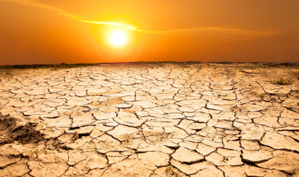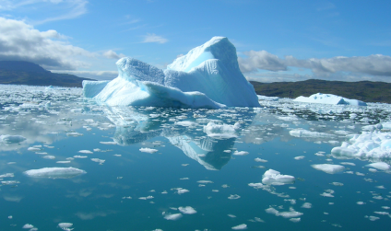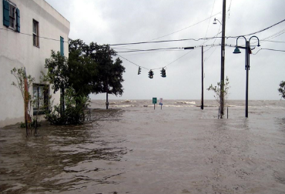

|  |
| --- |
| **Climate change** |
| |  |  | | --- | --- | | Natural causes | Human causes | | **Orbital changes**  The Milankovitch cycles  bring the earth closer  or further from the sun.  **Volcanic activity**  During a volcanic  Eruption CO2 is  released into the  atmosphere.  It can also block the  sun causing cooling. | **Burning fossil fuels**.  Gas, coal and oil which  release carbon  dioxide into the  atmosphere**.**  **Deforestation**  Trees absorb carbon  dioxide during  photosynthesis, if they  are cut down it releases  CO2 into the atmosphere.  **Dumping waste in landfill**  When waste decomposes it produces methane.  **Agriculture**  Releases nitrogen oxide  into the atmosphere. | |

|  |
| --- |
| **Impacts of climate change** |
| |  |  | | --- | --- | | **Global positive impacts** | **Global negative impacts** | | Energy consumption may decrease (because less need for heating)  Longer growing seasons for farming (agriculture)  Frozen regions such as Canada may be able to grow crops | Sea level rise will affect 80 million people  Tropical storms will increase in strength  Diseases such as malaria increase, another 280 million people may be affected  Species in affected areas (e.g. Arctic) may become extinct | | **UK positive impacts** | **UK negative impacts** | | Crops such as  oranges, grapes and  peaches can be  grown in the UK  Winter heating costs  will be reduced  Accidents on roads in winter will be less likely | Sea levels rise flooding low  areas e.g. east England  Scottish ski resorts may have  to close due to lack of snow  Drought and flooding  becomes more likely as  extreme weather increases  Water supplies under pressure as there is more need for water in hotter summers | |

|  |
| --- |
| **Plastic pollution** |
| Plastic waste has a physical impact on marine life: entanglement, ingestion, starvation. It has a chemical impact on the buildup of persistent organic pollutants like PCBs and DDT. It affects the transport of invasive species and pollutants from polluted rivers to remote areas in the ocean. |

|  |
| --- |
| **Sustainability** |
| Sustainability means ensuring that the planet and all of its resources can continue to provide a home for the humans, animals and plants that live here.  It is our job to take care of the planet to ensure that future generations of people and animals can live and thrive on Earth. |

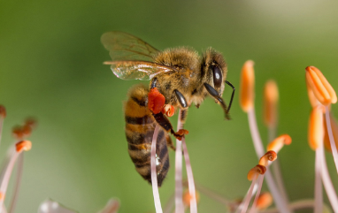

|  |
| --- |
| **Farming** |
| The food we eat has many environmental impacts. Making the way we produce and consume our food sustainable is vital in order to feed an ever-growing world population, whilst protecting our environment. Issues include:  1. Farming and the environment  2. Food miles  3. Food packaging and recycling  4. Food waste 5. Fairtrade |

|  |
| --- |
| **Temperature over time** |
|  |

