

**Anglo-Saxons and Vikings**

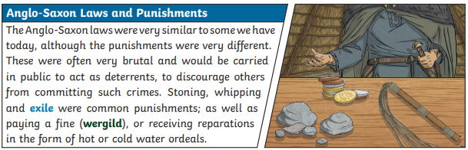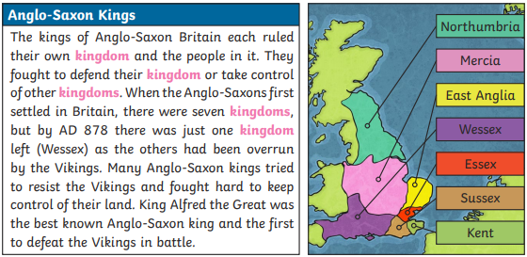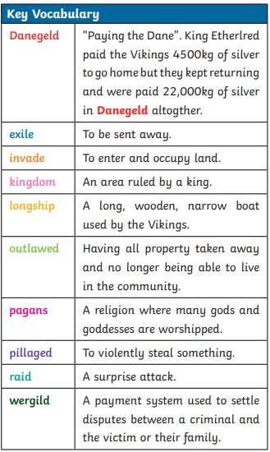

**Anglo-Saxon Place Vocabulary** Burh – town bury – fortified place ham/m – village croft – small enclosure field - open land ley – clearing ford – river crossing ings - ___’s people ney – island mer/mere – pool or lake stow/stowe – holy/meeting place wic/wich – farm worth/worthy - enclosure

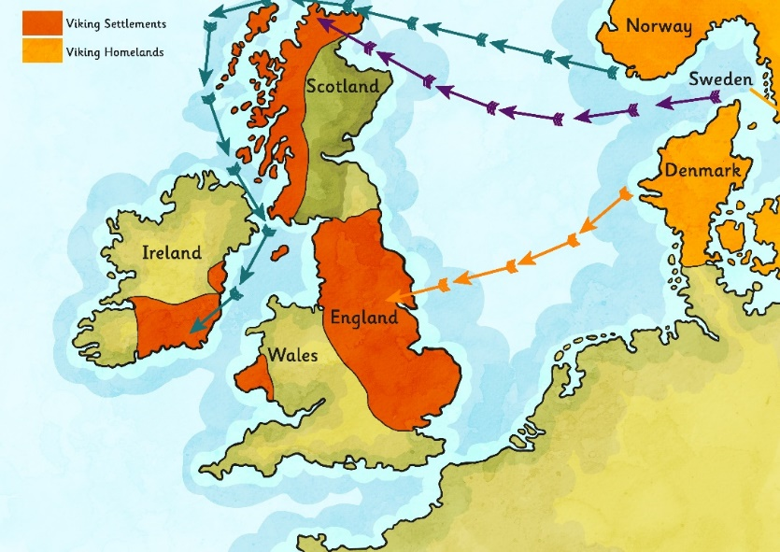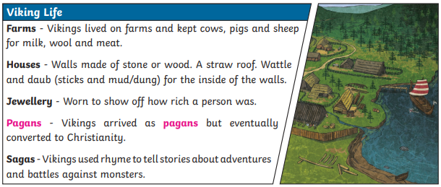

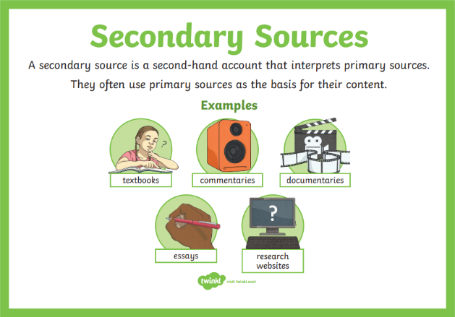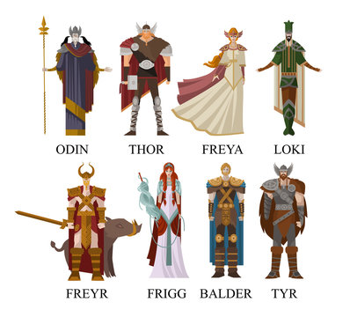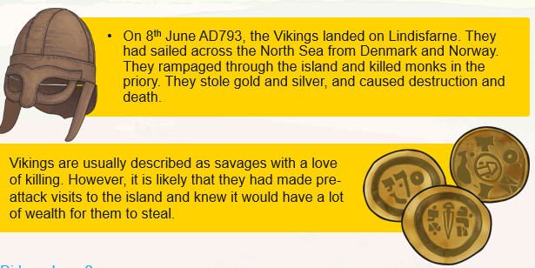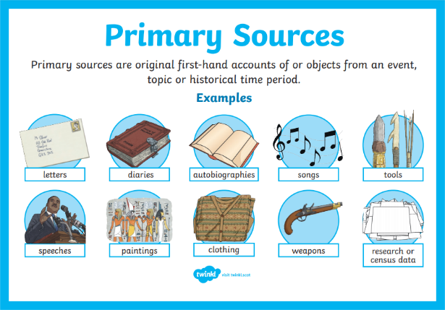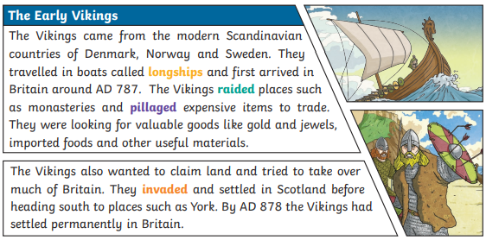

**Where did the Vikings come from?**

**Lindisfarne**

**Viking Gods**