

**Monarchy and Democracy - History**

|  |  |
| --- | --- |
| **Key Vocabulary** | |
| assassination | The murder of someone important. |
| empire | A large group of countries ruled over by a single monarch. |
| invade | To raid or enter another area as an enemy. |
| Magna Carta | A list of promises that would make England a safer and fairer place to live. |
| monarch | A person who rules over a place, usually king or queen. |
| rebels | A group of people who disobey or fight against a government |
| reign | To rule over a country as the monarch. |
| revolt | To join with others to fight against the government. |

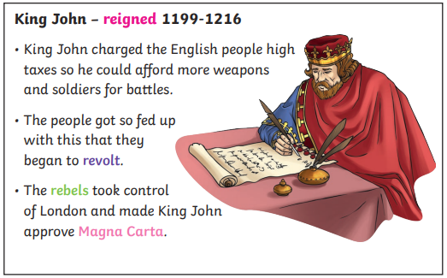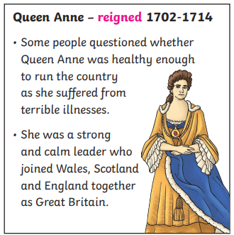

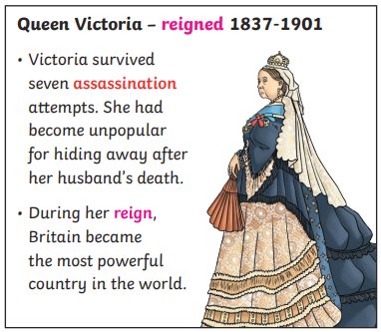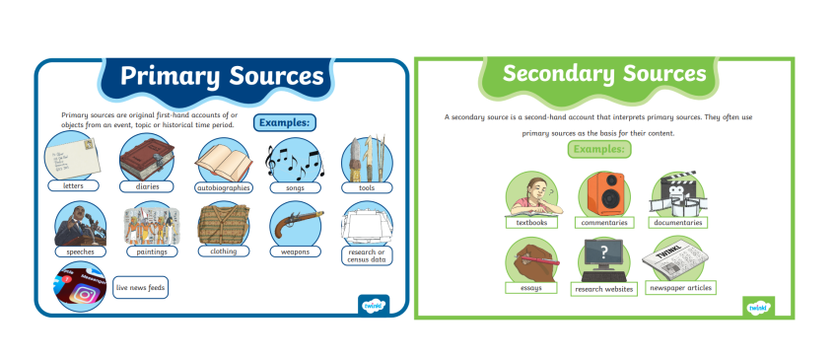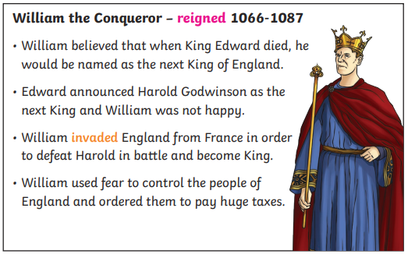



**Monarchy and Democracy– History and Geography**

