

**Year Two Topic ‘Ice’ Knowledge Organiser**

|  |  |
| --- | --- |
| **Key Vocabulary** | |
| Map | A drawing of a town, a country or the world. Maps show you where roads,  mountains and rivers are. |
| Globe | A ball/sphere with a map of the whole world. |
| Atlas | A book of maps. |
| Weather | The conditions you might notice when outside. |
| Season | One of the four parts of the year Autumn, Winter, Spring, Summer. |
| Country | A land with its own people and laws. |
| Continent | One of the 7 very large areas of land in the world. |
| Equator | An imaginary line around the middle of the earth. Countries near the equator are very hot. |
| North Pole | The area at the top of the world furthest from the equator. It is very cold. |
| South Pole | The area at the bottom of the world furthest from the equator. It is very cold. |
| Oceans | A huge body of salt water. There are 5 on Earth. |
| Physical features | Include: beach, cliff, coast, forest, hill, mountain, sea, ocean, river, soil, valley, vegetation, season and weather. |
| Human Features | Include: city, town, village, factory, farm, house, office, port, harbour and shop. |

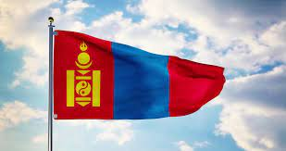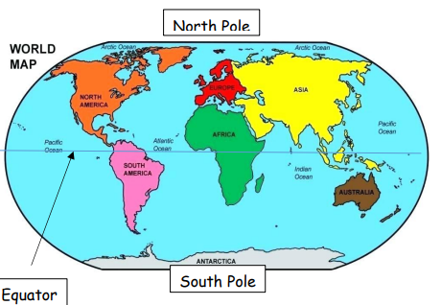

|  |
| --- |
| **Key Dates & Events** |
| Cold places: The North Pole is in an area called the Arctic and is at the very top of the globe. The South Pole is in the continent of Antarctica and is at the very bottom of the globe. They are both very cold, windy and have a lot of snow and ice. It’s even too cold for trees to grow! People can’t live at these places but some people live in regions near the North Pole. |
| Hot places: Areas on or near the equator are mainly hot and humid. The **equator** is halfway between the North Pole and South Pole. |

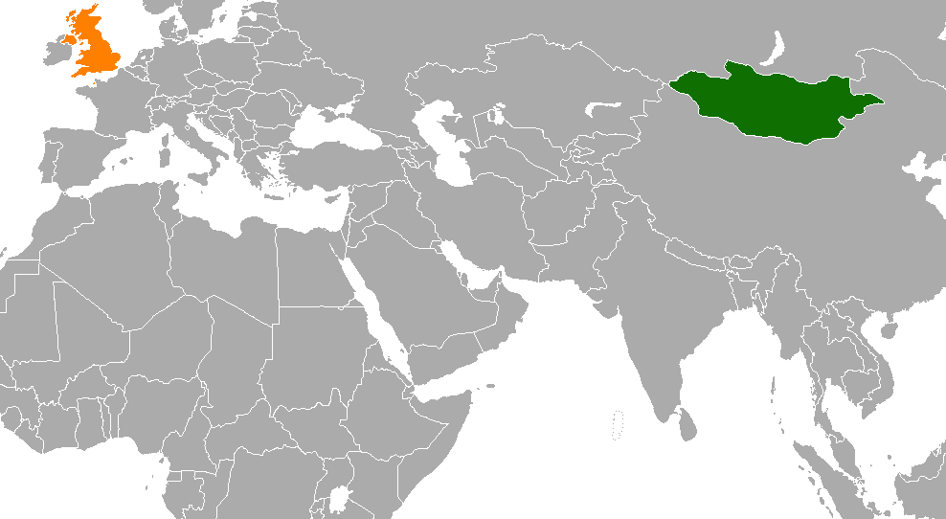

**CONTINENT OF EUROPE**

**CONTINENT OF ASIA**

**The United Kingdom**

**Mongolia**

The Mongolian Flag