

**Castles**

|  |  |
| --- | --- |
| **Key Vocabulary** | |
| Castles | A large building fortified against attack with thick walls, battlements, towers and sometimes a moat. |
| Battlements | The top of the castle wall with sections that allow people to fire arrows through |
| Portcullis | A strong iron gate that stops the enemy getting in. |
| Drawbridge | A bridge that can be lowered or raised to enter and exit a castle |
| Moat | A deep ditch that surrounds a castle. |
| Keep | A strong tower built inside the castle for defence |

**Roles in the Castle**

|  |
| --- |
| **Types of Castle** |
| Motte and Bailey    Keep and Bailey |

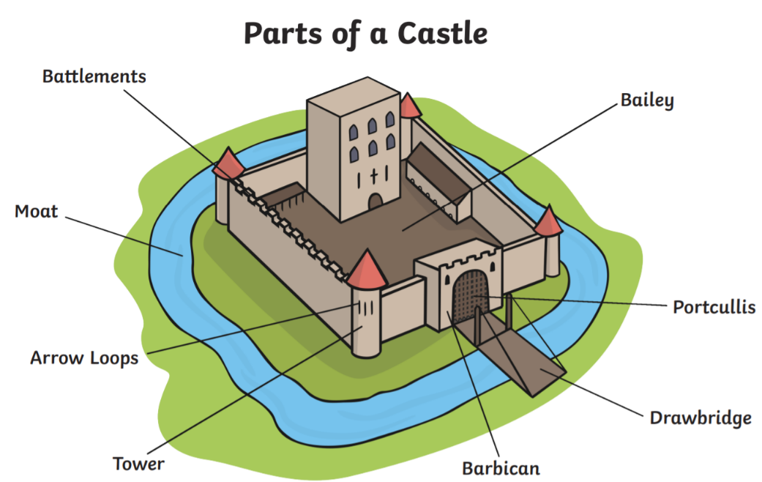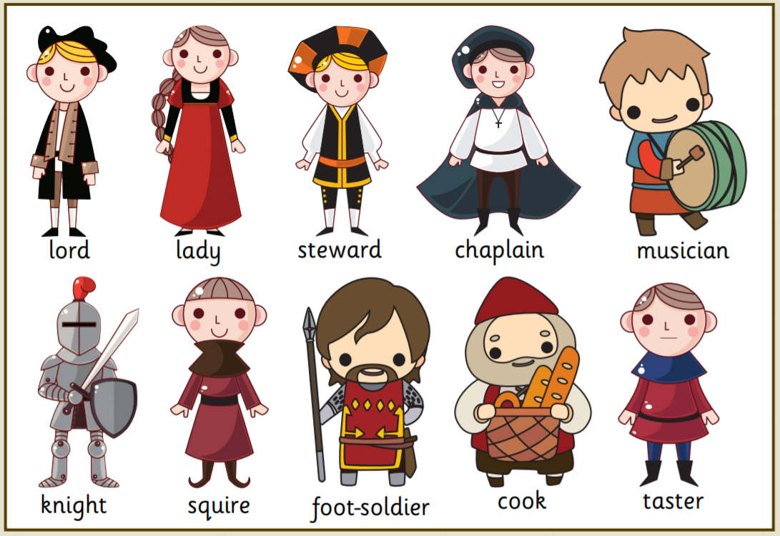

Kings and Queens, Lords and Ladies used to live in castles. In England we still have lots of castles but they are not used in the same way anymore.

The strongest castles were the hardest to get in. They had lots of defensive features such as a drawbridge, moat, keep, portcullis and battlements. Not all castles looked the same and some had different features which helped them to stay protected. They might have been built on a hill.



**Kings and Queens**

|  |  |  |
| --- | --- | --- |
| **Significant British Monarchs** | |  |
|  |  |  | |
| King Henry VIII | Queen Victoria | Queen Elizabeth II | |
| 1509-1547  He had 6 wifes.  He liked food, hunting and music.  He was mean. | 1837-1901  She was married at Prince Albert who introduced the tradition of the Christmas tree.  She had 9 children.  C:\Users\hnunn\AppData\Local\Microsoft\Windows\INetCache\Content.MSO\207597ED.tmpC:\Users\hnunn\AppData\Local\Microsoft\Windows\INetCache\Content.MSO\466ACA11.tmp | 1952 – present day  She was taught at home.  She liked art, music and swimming.  She married Prince Phillip and has 4 children.  She is the longest-reigning monarch.  C:\Users\hnunn\AppData\Local\Microsoft\Windows\INetCache\Content.MSO\466ACA11.tmp | |

|  |  |
| --- | --- |
| **Key Vocabulary** | |
| Monarch | A monarch is a king or queen, an emperor or a sultan. |
| Succession | This is the order in which a monarch’s family will take over the throne. |
| Parliament | This is where politicians meet to decide laws. |

