

**Music – Listening and Appraising**

What is the structure of the song?

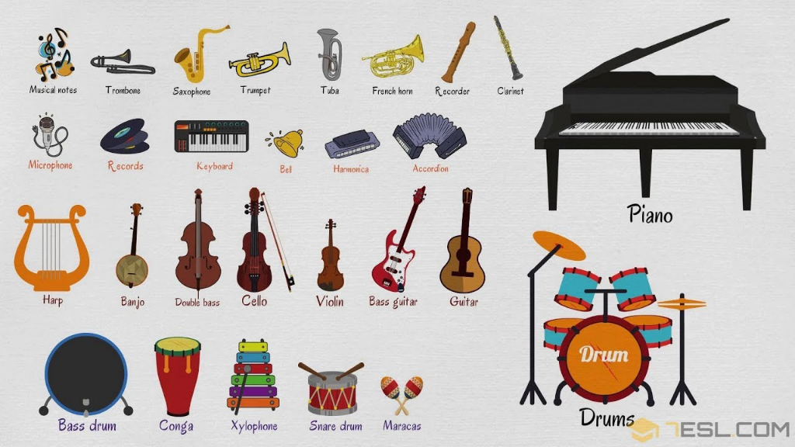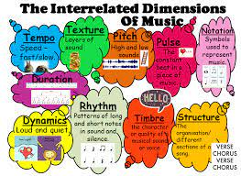

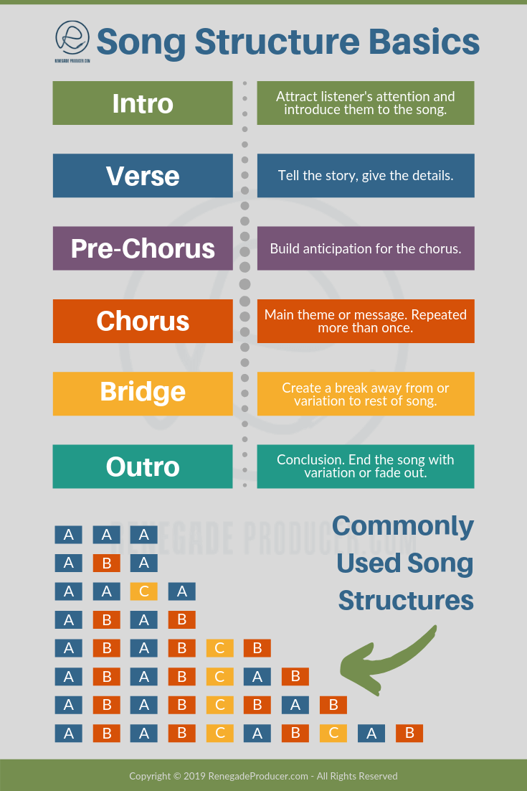

What instruments can you hear?

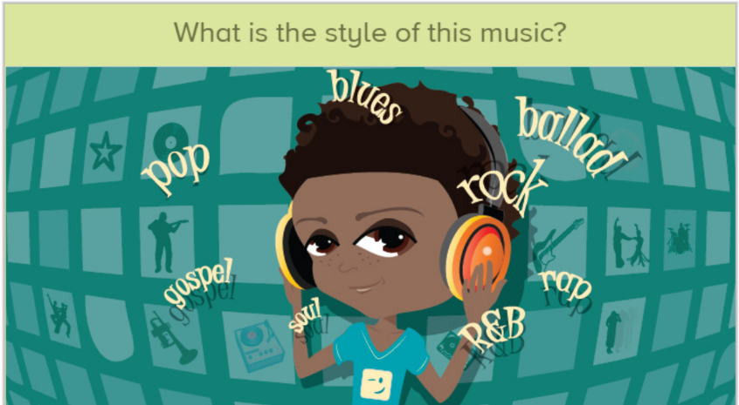

|  |  |
| --- | --- |
| **Key Vocabulary** | |
| appraising | Listning carefully and considering different aspects of music. |
| Introduction | Music heard at the beginning of a song or piece of music. |
| Verse | A section in a song which has the same tune but different words |
| Pre-chorus | A short section in a song, before the chorus |
| Chorus | A repeated section in a song which gives the main message. |
| Bridge | Contrasting section which leads back to main material. |
| Outro | Short section which bring the music to the end. |
| Recurring Theme | A tune that repeats again and again in a piece of music. |
| Style indicators | Identifiers which show us the genre of the music. |
| lyrics | The words of a song |

Do you like the song?



How does the music

make you feel?