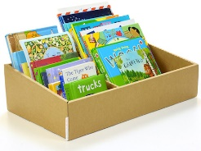 | Easter Holiday Reading Challenge |  |  |  |  |  | Easter Holiday Reading Challenge
Read wearing a hat |  | Read in the garden | 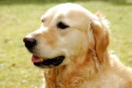  Read to a pet or an animal |  |  | Read wearing a hat |  | Read in the garden | Read to a pet or an animal
Read wearing pyjamas  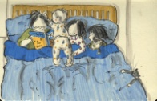 |  | Read a story that makes you happy | Read a non-fiction book about your class topic  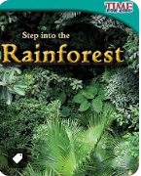 |  |  | Read wearing pyjamas |  | Read a story that makes you happy | Read a non-fiction book about your class topic
Read book by an author you've never read before  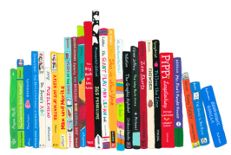 |  | 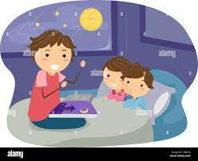  Listen to someone read you a bedtime story | Read in an unusual place (take a photo to prove it!) |  |  | Read book by an author you've never read before |  | Listen to someone read you a bedtime story | Read in an unusual place (take a photo to prove it!)
Tick each challenge that you complete and return this card to school after the Easter holidays. |  |  |  |  |  | Tick each challenge that you complete and return this card to school after the Easter holidays.

Name: __________________________  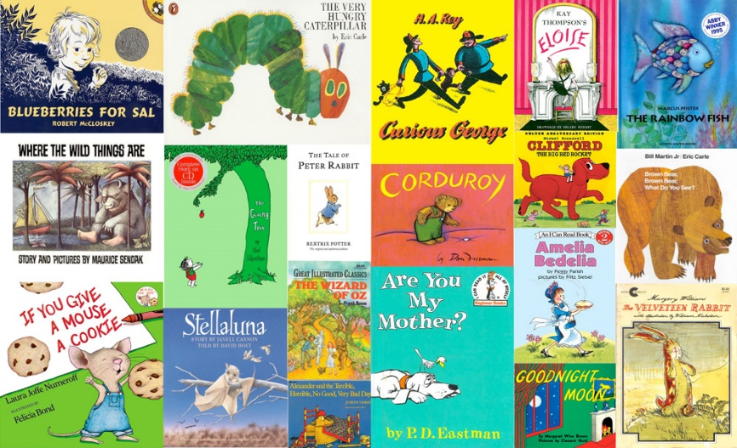  Year 3  Easter Holiday Reading Challenge |  | Name: __________________________  Year 3  Easter Holiday Reading Challenge

