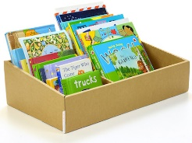 | Easter Holiday Reading Challenge |  |  |  |  |  | Easter Holiday Reading Challenge
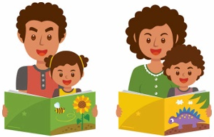  Take it in turns to read a page aloud with someone else |  | 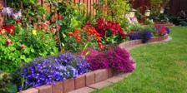  Read in the garden | 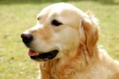  Read to a pet or an animal |  |  | Take it in turns to read a page aloud with someone else |  | Read in the garden | Read to a pet or an animal
Read in your pyjamas  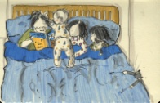 |  | Read a book that makes you happy | Read a book about your class topic  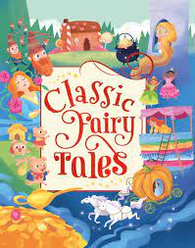 |  |  | Read in your pyjamas |  | Read a book that makes you happy | Read a book about your class topic  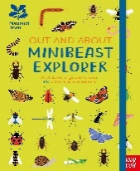
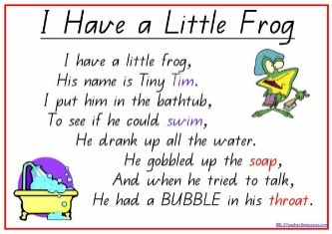  Read a poem or nursery rhyme |  | Listen to someone read you a bedtime story  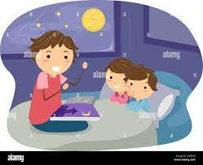 | Read in an unusual place (take a photo to prove it!) |  |  | Read a poem or nursery rhyme |  | Listen to someone read you a bedtime story | Read in an unusual place (take a photo to prove it!)
Tick each challenge that you complete and return this card to school after the Easter holidays. |  |  |  |  |  | Tick each challenge that you complete and return this card to school after the Easter holidays.

Name: __________________________  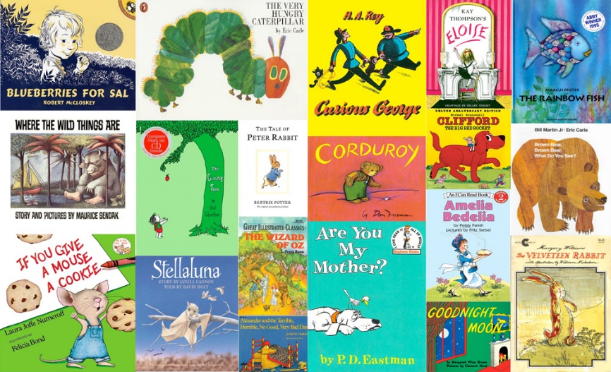  Early Years  Easter Holiday Reading Challenge |  | Name: __________________________  Early Years  Easter Holiday Reading Challenge

